A new artwork by Krzysztof Wodiczko at the Remembrance Hall at the Warsaw Insurgents Cemetery. The artist gives the voice to the witnesses of the Uprising.
Hall of Remembrance at the Warsaw Insurgents Cemetery, Museum of Warsaw branch
2 October 2023
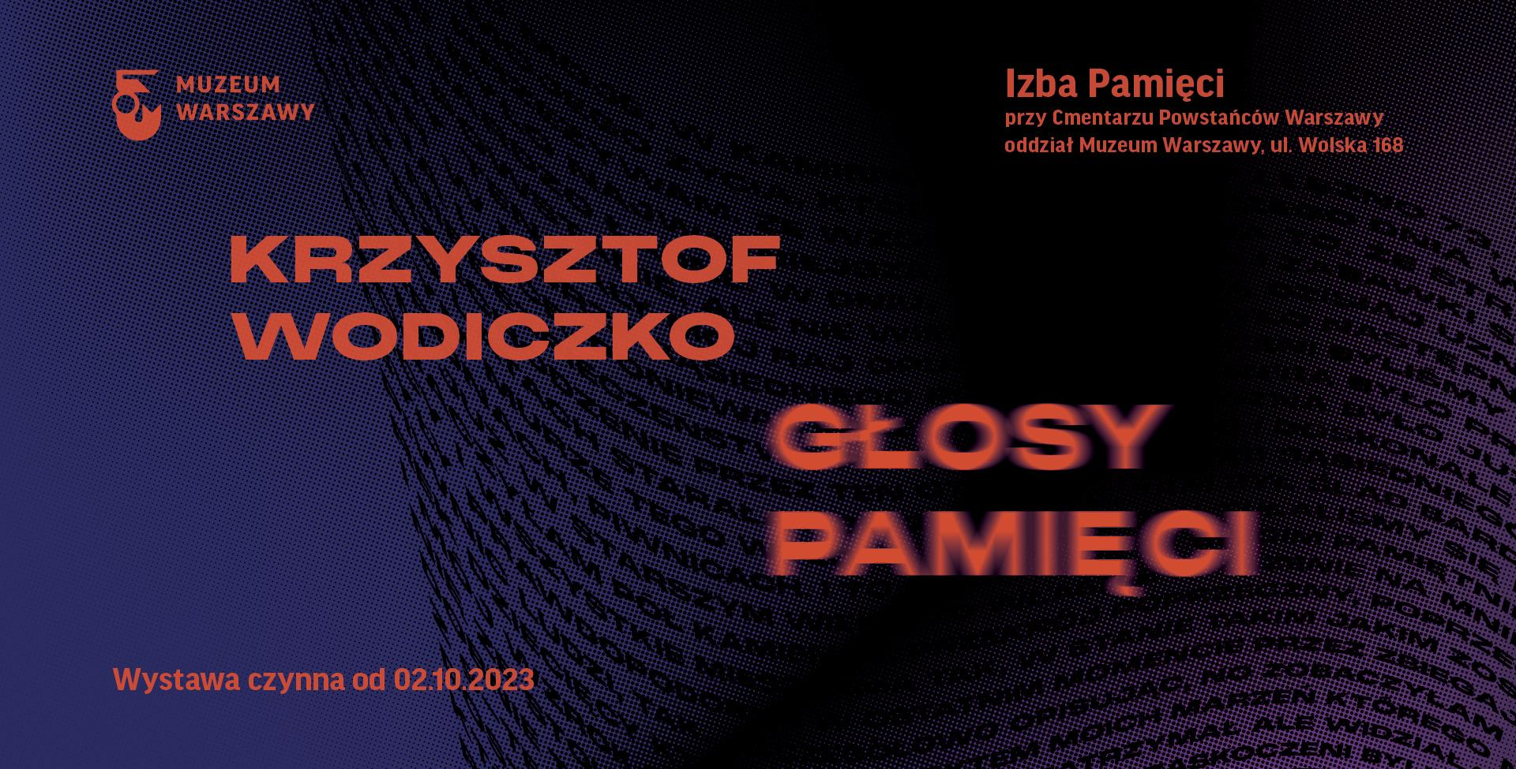design: Joanna Bębenek

On 2 October, a new permanent exhibition will be opened to public at the Hall of Remembrance at the Warsaw Insurgents Cemetery—a project by Krzysztof Wodiczko, one of the most celebrated Polish artists in the world. Voices of Memory audio-visual installation commemorates the victims of the Warsaw Uprising and tells the tragic stories of the civilian population of Warsaw in 1944.
Krzysztof Wodiczko is one of the most acclaimed audio-visual artists today. Born in Warsaw, he has lectured at the Academy of Fine Arts in Warsaw, the Massachusetts Institute of Technology and, currently, at the Harvard Graduate School of Design in Boston. He is the author of multimedia projects, installations in public space and essays on art theory. His most recent artwork—the audio-visual installation titled Voices of Memory—focuses on the tragic fate of the civilians in Warsaw, their courage, suffering and aid they provided to the insurgents in 1944. It deals in a deeply moving way with the sacrifice of Warsaw residents, driven out of their homes and murdered in mass executions. Created especially for the permanent exhibition at the Hall of Remembrance, the work is in line with the message of Wodiczko’s oeuvre—for years now, the artist has been engaged in anti-war activities, calling for “the art of un-war” and for establishing the World Institute for the Abolition of War.
Voices of Memory installation will become a focal point of the Hall of Remembrance pavilion. The exhibition hall will be filled with the accounts of witnesses to the Nazi crimes and of their relatives. Civilians, soldiers as well as the younger generations who carry the burden of the wartime events will be given their voice, among them Wanda Traczyk-Stawska and Tadeusz Rolke. The core of the installation will be the testimonies of people affected by the trauma of the Warsaw Uprising. Those personal stories, juxtaposed with one another, form a multi-layered and not-so-obvious portrait of Warsaw in 1944. The witness testimonies will be accompanied by the images of flames, propelled by the sound of human voice.
The opening of the new permanent exhibition will take place on 2 October, on the Remembrance Day of the Civil Population of Insurgent Warsaw. “The Hall of Remembrance’s role is to draw attention to those who are often forgotten in the narrative on the Warsaw Uprising—the common people. That is why the Remembrance Day of the Civil Population of Insurgent Warsaw is such an important day for us, and for the history of this city. We hope that this year’s opening of the permanent exhibition will launch an annual commemoration of that day at the Hall of Remembrance,” says Karolina Ziębińska-Lewandowska, the Museum of Warsaw Director. On the day of the opening, at 5PM, Bartek Wąsik will perform a piano concert, a culmination of the Reading the Uprising series. The vernissage will begin at 6PM.
Hall of Remembrance at the Warsaw Insurgents Cemetery is a symbolic site dedicated to the victims of the 1944 Warsaw Uprising. Tens of thousands of Warsaw residents have been commemorated in the two pavilions and on the Wall of Memory. The Hall of Remembrance’s goal is to restore the memory of the fallen men and women of Warsaw. It is a place where one can reflect upon the consequences of violence, radicalisms and armed conflicts.
Krzysztof Wodiczko – visual artist, lecturer at the Harvard Graduate School of Design, theoretician of art, laureate of numerous prestigious awards, i.a. Hiroshima Art Prize (1998), The György Kepes Fellowship Prize (2004) and Katarzyna Kobro Prize (2006) as well as the Gloria Artis medal (2009) granted by the Ministry of Culture and National Heritage.
The Voices of Memory project has been realised in cooperation with the Profile Foundation and the Embassy of Germany. The exhibition is financed by the City of Warsaw and the Ministry of Foreign Affairs of the Federal Republic of Germany. The Mayor of Warsaw is an honorary patron of the project.
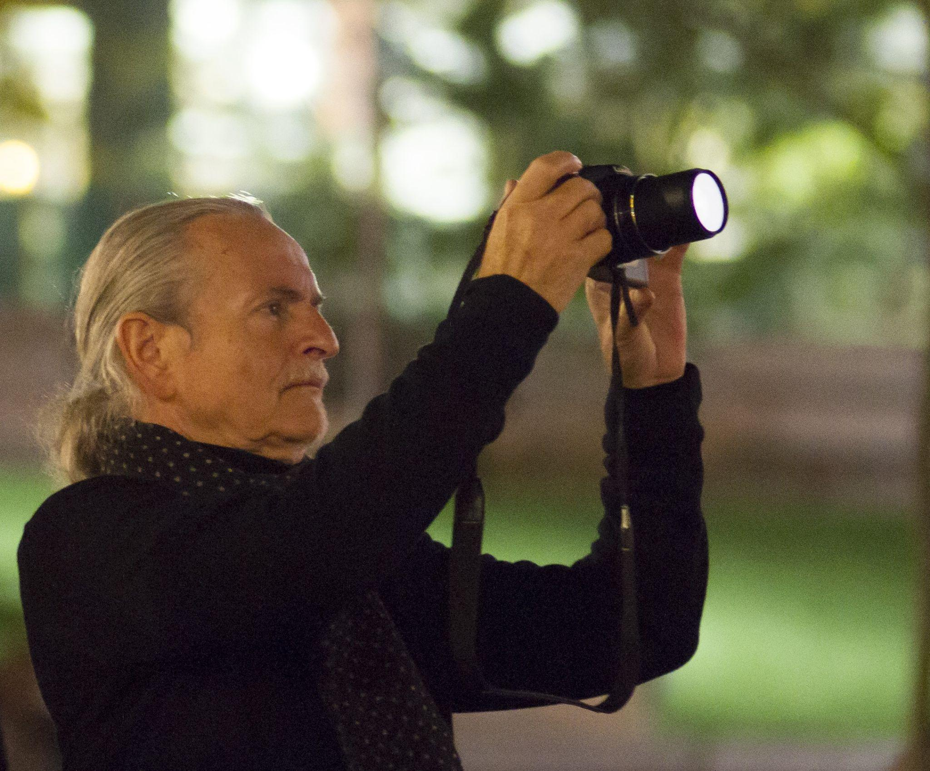
Krzysztof Wodiczko, Montreal, Quebec, Place des Arts, Canada, 2014 (during the Homeless Projection screening)

Krzysztof Wodiczko, Voices of Memory
The multimedia installation aims to express an opposition to all armed conflict. It is inspired by and based on the accounts of wartime experiences related to the Warsaw Uprising.

Conceived, written and directed by Krzysztof Wodiczko
Initiator of the project Jarosław Trybuś
Produced by Muzeum Warszawy
Associate producer Fundacja Profile
Executive producer Bożena Czubak

Interface development Jerzy Stypułkowski
Director of photography and camera operator Marcin Hiller
Sound postproduction Grzegorz Kucharski
Editor Łukasz Gregorek
Implementation Eidotech Polska
Project coordinators Olga Baron i Marta Galewska



More information at: https://izbapamieci.muzeumwarszawy.pl/

Contact with the media:
Julia Golachowska
Promotion and Marketing Department
Museum of Warsaw
tel. +48 22 277 43 94
julia.golachowska@muzeumwarszawy.pl

